PART I
- What are the 4 main sources of endogeneity:
A: 1. Omitted Variable; 2. Selection bias; 3. Measurement error; 4. Simultaneity
- Provide a formal definition of Selection Bias and show how it arises when (naively) comparing outcomes from two groups that are drawn from different populations.
A: Selection bias is a systematic error that occurs when the individuals or items included in a sample or study are not representative of the larger population from which they are drawn. In other words, there is a non-random or biased selection of participants, leading to a distorted or inaccurate representation of the population. It is a threat to the external validity of a study and its generalizability. For instance, a study that seeks to assess the prevalence of depression among young adults and samples its data exclusively from a self-help page on social media is likely to find a higher prevalence of depression in her/his sample than in the actual population.
- Derive the bias that results from omitting x2 in the model y = b1x1 + b2x2 + u?
The bias can be expressed as the difference between the estimated coefficient in the reduced model and the true coefficient: Bias = b hat 1 – b1. If there is no omitted variable bias, the estimate b hat 1 ​ should be an unbiased estimator of b1. However, if x2 ​ is correlated with both x1 and the error term (u), omitting x2 ​ can lead to biased estimates. In this case, the omitted variable bias can be expressed as: COV (x1,x2)* ((Var x2)^-1)*COV(x2,u).
- Simulate:
  - Answers in R syntax.
  - X1 = 2.99; X2 = 5.02; calculated bias in the model: 1.946717e-15. This is an omitted variable bias since the influence of x2 is not accounted for in this model.
  - The unbiased coefficient estimate for x2 is 5.87, assuming a 95% confidence level, we can be “sure” that the mean is within [5.79, 5.95].
- Follow all the other steps in the slide deck.
- Example 1 What type of endogeneity does this example highlight?
Omitted variable bias. This seems to be a spurious correlation (other omitted variables are likely responsible for this correlation)
- Example 2: What type of endogeneity does this example highlight?
Omitted variable bias.
Which source of Endogeneity do you consider to be the largest problem for your work. Explain why?
Omitted variables seem to be the biggest problem for me as I start working with secondary data. This is because it’s hard to anticipate conceptually all possible variables that may influence my model apriori. I feel like I can still have a super thorough conceptual model and accidentally end up omitting a few relevant variables in the process, which could bias my estimations. When it comes to experiments though, measurement error is typically a big problem in my opinion. This is because we’re interested in causality, so making sure that we’re measuring the right constructs accurately, reliably, and validly becomes increasingly important to establish the right causal relationships > e.g. for mediation analysis, this can be a pain).

PART II
OLS
BACKGROUND: To show that the OLS estimator is unbiased, we want to prove that: E(β^​j​)=βj. Where E(β^​j​)=βj ​ means that the expected value of the estimated coefficient β ^j​ is equal to the true population parameter βj​. In other words, the average value of the estimates over many possible samples is equal to the true underlying value.
The OLS estimator for the coefficient βj is given by the following expression:

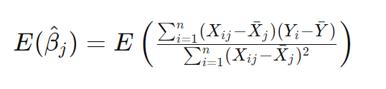
Where Xi​ are the i observed values of the independent variable (e.g. if we had 100 observations of MBA basketball players’ height, xi could take any value of height of any of the 100 MBA players in the sample). Xˉ is the sample mean of the independent variable x (e.g. mean height of the 100 MBA basketball players). Yi is the i observed values of the dependent variable (e.g. number of dunks in the MBA of any of the 100 players). Yˉ is the sample mean of the dependent variable (e.g. average number of dunks in the MBA among the 100 players). Xi​- xˉ is the deviation of each xi​ (observed x value) from its mean > For instance, Michael Jordan’s height relative to the mean height of the 100 MBA players. Conversely, Yi​- yˉ is the deviation of each yi (observed y value) from its mean > For instance, the number of dunks Michael Jordan performed relative to the mean number of dunks performed by the 100 MBA players. The portion of the expression below:
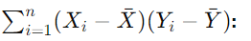 is the sum of the cross-products of the deviations of X and Y from their respective means, and it measures how X and Y vary together (Covariance) > back to my example, this portion would capture how all deviations in the 100 MBA players’ number of dunks from the average number of dunks among the 100 players varies as their individual height deviate from the average height of these 100 players. This part of the expression allows us to determine the direction and strength of the linear relationship between X and Y. Concerning the bottom half of the expression:
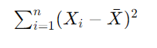This is the total variability of the values of X around their mean (squaring ensures that negative deviations do not cancel out positive deviations). It measures the spread or dispersion of the independent variable X, and it is used to standardize the covariation between X and Y when estimating the slope E(β^​j​). This helps in quantifying the strength of the linear relationship between X and Y.

PROOF: starting form a simple linear regression model: Yi​=β0​+β1​Xi​+εi​, we can derive the coefficient estimator (β^1):
​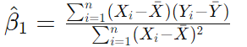

We want to show that the expected value of the OLS estimators is equal to the true population parameters. Therefore,
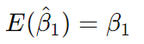
The expected value of β^1 can also be represented as:
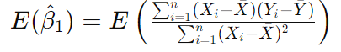
At this stage, we can apply the linearity of expectations (this is the notion that the expected value of the sum is the sum of expected values, regardless of how the random variables are related):
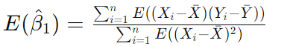
We can apply the assumption that the regression error is mean independent of the covariates and has mean zero (zero conditional mean assumption). In other words, since we know that E(xi-xˉ) = 0 and that E(yi-yˉ) = 0, we can also derive the expected value of the product (which will also be 0):
Plugging 0 into the expression of E(β^1), leads to 0, as 0 divided by anything still yields 0.
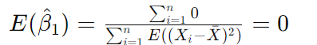

Endogeneity:
A)
We can express the new linear OLS model as:
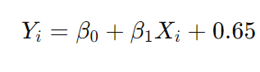
And its coefficient estimator as:
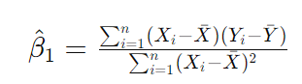

Given the OLS model specification, the coefficient estimator could thus be written as:
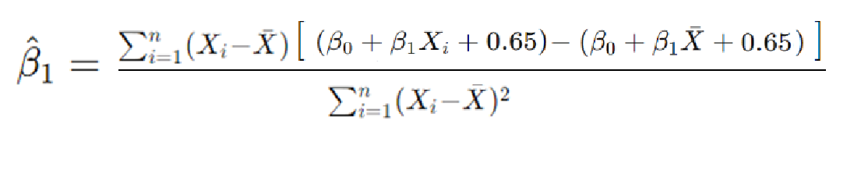
Simplifying the expression yields:
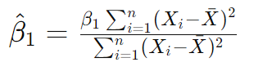
In this case, the term cancels out in both the numerator and denominator, leading β ^1 be equal to β1. Therefore, despite violating the non-zero conditional mean assumption introduced by E(u∣X)=0.65, the estimate does not seem to be biased.
B) 1. Omitted Variable; 2. Selection bias; 3. Measurement error; 4. Simultaneity.
C) Selection bias.
D) 1. Omitted Variable:
Regressed number of drownings in Portugal in July on number of ice creams sold in Portugal in July.
Found that ice cream consumption leads to drowning.
But this spurious correlation is due to an omitted variable that increases both simultaneously: July is summertime.

2. Selection bias:
Regressed salary on education (measured as years of schooling) on salary.
Found that more education leads to higher salaries.
But those who are unemployed don’t have a salary.

3. Measurement error:
Regressed likelihood of developing a chronic disease on BMI.
Found that changes in BMI did not affect people’s likelihood of developing a chronic disease.
But BMI was self-reported and was thus prone to social desirability bias.

4. Simultaneity.
Regressed Denmark’s economic output (GDP) on the country’s investments.
Found that the more investments there were, the higher was Denmark’s GDP.
But at the same time, the higher a country’s GDP, the more investment there is in the country.

REGRESSION EXERCISES:
- Steps can be followed with my syntax file.
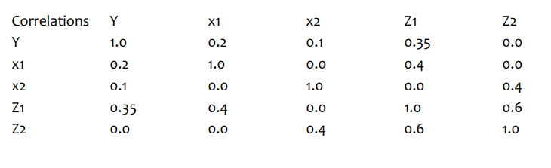

To me the values between both matrices are quite different. This is expected, as each variable was created randomly, without specifying means or variances. In other words, it is expected that my Y,X1,X2,Z1, and Z2 will each differ in their distribution relative to the same variables created for the table on top. Moreover, the table given was a Var-Cov Matrix and I created a covariance matrix. In other words, I calculated the sum of the cross-products of the deviations of two variables (e.g. X1 and Y) from their respective means, which measures how 2 variables vary together:

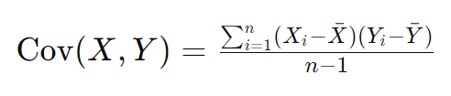

In the table on top the same was done, but with an added step: normalizing the covariance between the variables. Note: this can be noticed for instance when we look at the correlations between the same variables such as Y and Y, or X1 and X1 in the second table relative to the table on top. Expressly, since I didn’t normalize the covariances, their covariances allow for values below or superior to “1”. Once the covariances are normalized, the covariance of the same variables (e.g. Y and Y) are not allowed to differ from 1. Indeed, once covariances are normalized, they can only take values between -1 (absolute negative correlation) and 1 (absolute positive correlation).

- Univariate Regression (see R syntax to check steps)
- In this case, the estimated coefficient of X on Y can be expressed as:
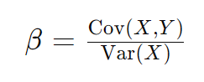
Therefore, we can simply divide the (X1,Y) covariance from the table by the variance of X1. The calculated coefficient was = -0.017416.

- As expected, I obtained exactly the same coefficient: -0.017416.

- Multivariate Regression (see R syntax to check steps)
a+b)
Covariance Matrix (same values as before)

- The estimated betas are identical to the covariances in the table above (β ^1 = -0.01741639; β ^2 = -0.01020655)
- See syntax in R
- Running the standard regression command yielded slightly different betas: β^1 = -0.007469; β^2 = 0.014249. This makes sense, as before (3c) I was looking at the covariance of X1 and Y and X2 and Y in isolation. Allowing both X1, X2, and Y to covary simultaneously leads to slightly different betas, as the regression model produces a beta (e.g. β ^1) that accounts for the covariance of two variables (e.g. covariance of X1 and Y) while accounting for the covariance of the remaining variables in the model (e.g. covariance of X1 and X2, covariance of X2 and Y).

- a+b+c) In univariate regression, the coefficient β^1 ​ represents the change in the dependent variable (e.g. Y) given a change in the independent variable (e.g. X1). The interpretation of β^1​ in this model is straightforward as it captures the relationship between X1 ​ and Y in isolation. The interpretation of β^1 ​ in the multivariate context is influenced by the presence of other variables. It represents the unique contribution of a variable (e.g. X1) ​ to the prediction of Y after accounting for the effects of other variables (e.g. X2) – partial effects. Moreover, in a multivariate model, if an independent variable (e.g. X1) is correlated with other independent variables (e.g. X2), theory predicts that the coefficient β^1 should differ from the coefficient in the univariate regression. In our case, the correlation between X1 and X2 is quite weak, so the coefficients barely change from the univariate to the multivariate regression.

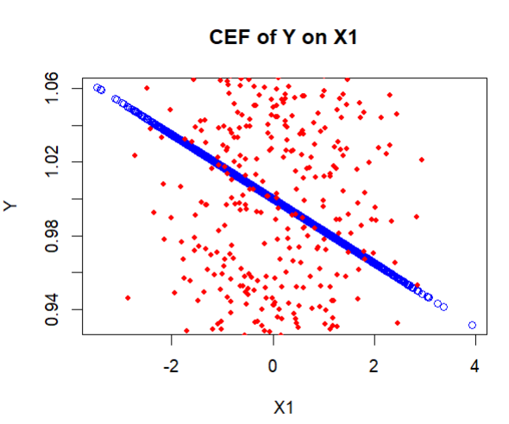
The graph shows that as X1 increases, the expected value of Y decreases. Of note is that the data is highly dispersed around the regression line. This is in line with my results from questions 2,3 and 4. Expressly, we calculated the β^1 for X1 in questions 2 (in a univariate model) and 3 (in a multivariate model), which gives us the expected change in the mean of Y for a one-unit change in X1 while holding any other variables constant. In both cases (Q2 &Q3), we found, on average, that as X1 increases Y decreases marginally. However, not all observations of Y given X1 necessarily adhere to this pattern. Indeed, the CEF for (Y | X1) represents the expected value of Y at a specific level of X1. In other words, it shows how the expected value of Y changes as X1 varies, while holding other variables constant (e.g. in our case X2). To illustrate this, I have marked two datapoints (purple points) in the CEF for (Y | X1) graph below to illustrate that not all values of X1 map onto lower levels of Y1. In summary, the CEF provides a more nuanced view of the relationship between Y and X1 at specific values of X1, while the coefficient β^1 in the linear regression model(s) give an average effect across the entire dataset.
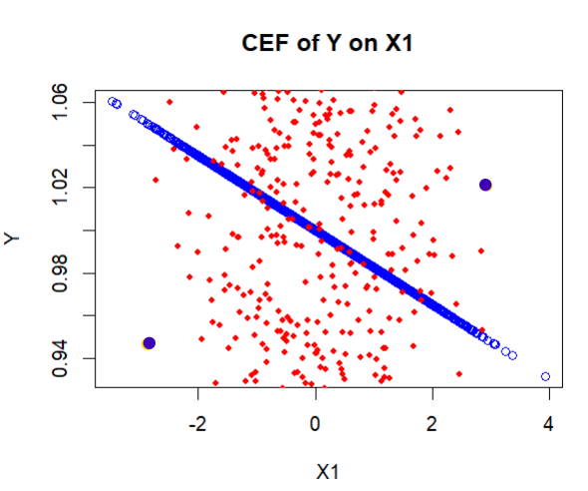

It was unclear whether a a correlation or a Var-Cov matrix was given (the table says correlations, the text says Var-Cov matrix), so I assumed the given table depicted a Var-Cov matrix.

